Chapter 3 - Enforcement
This chapter introduces authorization attributes (groups and privileges) and provides a discussion of access control that covers the three most common strategies in use today, including role-centric security. Although this chapter does introduce security descriptors and DACLs, it defers most of these details to Chapter 6 and remains focused on concepts and application design. The chapter also addresses the session-oriented nature of Windows security and how this affects your applications.
If you're reading chapters out of order, I recommend that you read this chapter before moving on to Chapter 6.

Authorization
If authentication answers the question "Who are you?" then authorization answers the question "What can you do?" There are a number of ways of answering this second question, and in many secure systems (including Windows) the answer takes the form of authorization attributes. The most obvious authorization attribute is the principal SID, since it's possible to grant or deny access directly to individual principals. However, this doesn't scale very well when administering nontrivial systems, so another type of authorization attribute is needed, the group.
By creating several groups, and granting access permissions to these groups as opposed to individual principals, an administrator makes it very easy to add new principals (or remove old ones) while preserving a consistent security policy. For example, if a particular database on the network is used for contact management, and the sales department needs access to it, the administrator can create a group called Sales and allow anyone in Sales to access the database, without having to explicitly list each principal. Anyone looking at the security policy for the database would see immediately that Sales was allowed to use the database, no matter who happened to be in the Sales department on any given day.
Another type of authorization attribute is called a privilege. Whereas groups are used in access control decisions dealing with individual objects, privileges control security policy decisions in a more sweeping fashion, as will be demonstrated a bit later.

Groups
An administrator can configure a group account in the domain security database, containing all the SIDs that belong in the group. The idea is that if Alice is assigned to a group, her security context will include an authorization attribute (a group SID), and she can be granted (or denied) access on the basis i of this SID just as easily as she can be granted or denied access on the basis of her unique principal SID. Alice's authority is responsible for storing her group I assignments and making these authorization attributes (group SIDs) available to any servers that authenticate Alice.
Groups are typically used to model an organization; for instance, a set of groups such as foo\sales, foo\engineers, and foo\staff makes an administrator's job much easier when someone new joins the organization. Groups can be nested in Windows 2000. (This wasn't possible in earlier versions of Windows.)

Aliases and Roles
To make the model more flexible, an extra level of indirection is possible via the use of an alias (these are exposed to administrators as "local groups"). Aliases are similar to groups in that they represent a categorization of principals, but there are some major differences. Like groups, Windows identifies aliases via SIDs. Unlike groups, however, aliases are managed by the local security authority; an alias may be defined on any machine. This means that aliases have limited scope; in other words, if machine A defines an alias and assigns it to Foo\Alice, machine В won't ever know about this assignment. (Imagine if it didn't work this way – machine В would have to communicate with machine A and every other machine on the network to discover the aliases assigned to Alice.) This level of indirection is important for a couple of reasons: It helps deal with large organizations that have multiple cooperating authorities, and it can be used to decouple development-time and deployment-time constraints.
Say, for example, that AlicesMachine exposes resources (databases, files, printers, etc.) that are used by Foo\Sales and Bar\Accounting. By creating an alias AlicesMachine\TrustedDepartments and including Foo\Sales and Bar\Accounting in that alias, it is easy to grant access to both groups simultaneously by simply granting access to the alias. Later, if Quux\Marketing needed to be granted access to the same set of resources, it could also be added to the TrustedDepartments alias.
Aliases can include principals or groups from any authority, but may not include other aliases (this limitation exists even on Windows 2000). On Windows 2000, where groups can be nested, aliases are less critical than on Windows NT 4, where group nesting is not allowed.
Aliases were designed to help decouple design- and development-time decisions from deployment-time decisions. Developers understand how their application fits together, including which subsystems need to have access to other subsystems. At design and implementation time, certain logical roles are evident; for instance, Supervisors, Staff, and Customers might be the logical roles for an application that simulates a pet store. Customers are allowed to purchase and pet the animals, staff are allowed to feed the animals, and supervisors are allowed to give raises. These constraints are all known at design time. At deployment time, the store manager (Bob, say) installs the software, but doesn't know the details of the implementation (for instance, Bob doesn't know what access permissions need to be granted to various subsystems in the application). However, if the pet store software provides the list of logical roles, Bob can clearly provide concrete mappings for each logical role: For instance, BobsPets\Bob is the supervisor, BobsPets\Contractors and BobsPets\Employees are considered staff, and Everyone is considered a customer (Figure 3.1).

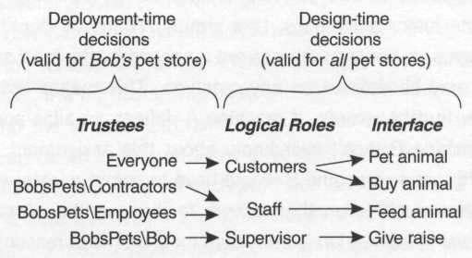
Figure 3.1. Logical roles

If the pet store software created three aliases when it was installed on Bob's machine, PS_Supervisors, PS_Staff, and PS_Customers, then all Bob has to do is add principals and groups to these aliases using the administrative tools built into Windows itself. Of course, the pet store application should describe the semantics of each of these roles in the documentation of the product. The developer can use these hardcoded aliases (discovering their actual SIDs dynamically via LookupAccountName) to make decisions at runtime, no matter where the product ships.
Another good example of logical roles (implemented using aliases) can be found by looking at Windows itself. Consider the Administrators alias on a machine: this acts as a logical role that defines who administers that machine. Any process running on that machine with a token containing the Administrators alias has administrative privileges there. The operating system often looks for this SID directly and grants or denies access based on its presence or absence; you can install services on a machine if you have this SID in your token. In a typical organization, how does a principal normally get included in this powerful role? The answer is that whenever you join a machine into a domain, the machine automatically bestows the Administrators role on the Foo\Domain Admins group (where Foo is the domain being joined). This shows how aliases and groups are designed to work together. The administrator of the Foo domain simply has to keep the Foo\Domain Admins group up to date, and all his or her administrative staff will have administrative privileges on all computers in the domain. The group is used to allow the administrator to model the organization, and the alias is used in an implementation-specific way in an application (in this case, the application is the operating system itself).
Using aliases this way is powerful but has a couple of drawbacks. First, all aliases on a machine live within the same namespace; note that in the pet store example I used a "PS_" prefix for each alias in a feeble attempt to avoid conflicts with other applications. Second, aliases are a machine-specific phenomenon, and there is no built-in infrastructure for pushing these definitions to a server farm. (The pet store example probably wouldn't require this, but many distributed applications care quite a lot about scalability.) Therefore, Microsoft Transaction Server (MTS) introduced (and COM+ carried forward) the notion of application-specific roles, and provided infrastructure for propagating them (along with other application and component attributes) to machines in a server farm. COM+ roles are discussed in more detail in Chapter 9, but if you understand the previous examples, COM+ roles are just another way to implement logical roles in an application.

Privileges
Imagine a directory structure as depicted in Figure 3.2, and imagine using the built-in Windows file system security editor to adjust the access control settings for directory A to deny all access to Alice. Then, on the file in directory C, grant Alice all access to that file. If Alice knows the full path to the file (\a\b\c\c.txt), will Alice be granted or denied access when she attempts to open the file via CreateFile? Clearly, she has been granted access to the file, but should she even be able to see the file, considering that she's not allowed to see what's in directory A?

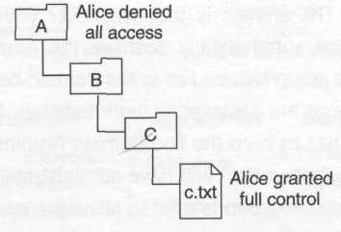
Figure 3.2. An access control puzzle

Whenever I ask this question in a class or at a conference talk, about a fourth of the people think that she'll be granted access, and another fourth think that she'll be denied. The other half scratches their heads because they are surprised that they've never thought of this before.
The answer to the question is that it's up to the administrator of the machine to choose a policy, and the choice is determined via an authorization attribute known as a privilege. Privileges help administrators deal with global policy decisions like this one, and provide the flexibility to allow certain groups of users to be treated differently than others.
The privilege in this case is "Bypass traverse checking", and it's granted to Everyone by default. So it turns out that the answer to this question can be determined by the administrator of the machine, either on a global basis (by granting Everyone or no one the privilege) or on a per-principal, per-group, or per-alias basis. This is a particularly good example of one of the many privileges defined by the operating system. (See the appendix for a comprehensive list of privileges and what they mean.)
Privileges, like aliases, are local settings that apply to the machine where they are set, and to no other machines on the network. The administrator of a machine may grant privileges to individual principals, groups, or aliases, and when a principal establishes a logon session on that machine, he or she is granted the union of all privileges assigned to the principal's account directly or to any groups or aliases in which he or she is a member.
It seems as though system administrators of nontrivial enterprises must have a heck of a time making global security policy decisions, because privileges are local settings and are not global to the domain. To help the administrator provide a consistent security policy throughout the enterprise, Windows 2000 provides a group policy infrastructure (exposed via the directory service), which helps automate control over these per-machine settings. At runtime, Windows 2000 automatically applies these policies (which can control privilege assignments). The local policy object (managed by the LSA) allows localized customization of security settings, but only where the group policy doesn't provide a particular setting (group policy decisions by the domain administrator always take precedence over local policy decisions). In earlier versions of Windows NT, there was a separate tool called the Security Policy Editor, which was much more primitive but allowed an administrator to automate privilege assignment (as well as other registry settings) throughout the machines in the domain.

Discovering Authorization Attributes
Ultimately, the operating system and third-party applications need to be able to enumerate the authorization attributes (groups, aliases, and privileges) for each principal that requests service. For convenience and efficiency, this information is physically accessible via the token. Imagine that alice@foo.com establishes an interactive logon session on AlicesMachine. The Local Security Authority on AlicesMachine authenticates her (with some help from the foo.com authority), creates a logon session and a token, and populates the token with global authorization attributes (group SIDs) from Alice's authority, followed by local authorization attributes (aliases and privileges) from AlicesMachine (Figure 3.3).

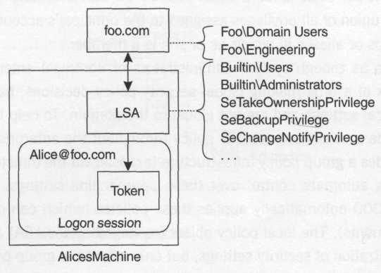
Figure 3.3. Constructing a token

If Alice then launches a monolithic application and starts requesting services by clicking buttons or typing commands, the application only has to look at its token to discover all Alice's authorization attributes. The application knows Alice's intentions based on the buttons she presses or the commands she types, and can therefore enforce an appropriate access control policy.

Distributed Applications
In a distributed application, things look much different. In this case, there are (at least) two processes involved, and they live on different machines: the client application (which may be a full-fledged native Windows application or simply a Web browser) and the server application. In this case, the server application is typically running long before any arbitrary client comes along, and will typically provide service to multiple clients simultaneously via the use of threads. Because the server process must be launched before any client can make requests into it, the server process itself must run under its own private logon session and therefore will not be able to simply peek at its process token to discover an arbitrary client's authorization attributes. Instead, the server and client processes (and often the client's authority) will engage in a network authentication handshake (described in Chapter 7). Based on the results of this handshake, the LSA on the server machine constructs a network logon session to act as a badge for the client on the server machine, and produces a token for that session. This token can be thought of as a proxy (or stand-in) for the remote client, because it looks somewhat similar to a token that would have been produced for the client had the client logged in to the server box interactively. The authorization attributes in this new token contain the groups for the client (as specified by the client's authority), as well as the aliases and privileges that have been assigned to the client on the server machine. Figure 3.4 demonstrates this.

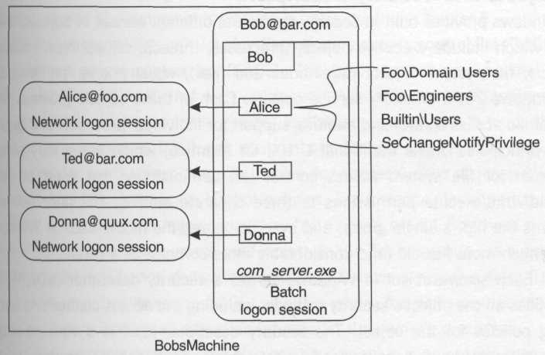
Figure 3.4. Server juggling client token

A distributed application will thus often need to juggle several tokens simultaneously: One token represents the logon session for the server process itself, and the other tokens represent the clients who are making various requests of the server. The server gleans the client's intentions via the COM method call or HTTP request, and just as in the monolithic application described earlier, it can now enforce an appropriate access control policy.

Objects and Security Descriptors
Windows provides built-in security for several different classes of objects, some of which include executive objects (processes, threads, semaphores, sections, etc.), file system objects (directories and files), registry keys, printers, and Windows 2000 directory service objects. Each of these objects provides fine-grained access control and auditing support for individual principals and groups of principals. Unlike traditional UNIX, for example, which has a very simple model for file system access control (an administrator can grant or deny read/write/execute permissions to three separate entities: the principal who owns the file, a single group, and everyone else), the model used in Windows is much more flexible (and considerably more complex as a result).
Each secure object in Windows carries a security descriptor (SD), which houses all the object's security settings, including the access control and auditing policies for the object. The security descriptor itself is a variable-length structure, primarily because the four data structures it contains are also variable length: an owner, a group, and two access control lists (Figure 3.5).

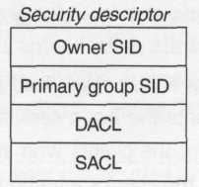
Figure 3.5. Anatomy of a security descriptor

The group is technically called the primary group, and exists for compatibility with the (UNIX-like) POSIX subsystem, which requires that an owner and a group be designated for each object. This text generally ignores the primary group because it isn't important outside the scope of the seldom-used POSIX subsystem.
The owner of an object is generally the person who created the object in the first place, and is implicitly granted certain permissions. This method keeps people from accidentally locking down an object so that nobody at all has access to it (even to delete it). Ownership is covered in more depth in Chapter 6.
The access control lists consist of a discretionary access control list (DACL) and a system access control list (SACL). The DACL (pronounced so that it rhymes with "jackal") is the list with which most Windows users are familiar – this list controls which principals, groups, and aliases are allowed to touch the object in various ways. A DACL can contain both positive and negative entries (positive entries grant access; negative entries deny access), thus allowing Alice to choose sophisticated access control policies. For instance, for a particular file, Alice can choose the following policy: "All Friends except Bob have read access". In this case, Alice grants read access to the Friends group via a positive entry in the DACL, and denies read access to Bob via a negative entry. The owner of an object controls the DACL, which is where the word discretionary comes in. Permissions on an object are granted at the owner's discretion.
The SACL controls auditing, and also can have positive and negative entries. In this case, however, a positive entry means "add an entry to the audit log if someone with this SID requests this type of access and it is granted," whereas a negative entry means "add an entry to the audit log if someone with this SID requests this type of access and it is denied."
Both access control lists employ an inheritance model, which is very simple in earlier versions of Windows NT but gets considerably more complex in Windows 2000. (Before you start to shiver, the Windows 2000 inheritance model is tremendously easier to administer and leads to more predictable behavior and a more maintainable system.) Inheritance simplifies the management of large object hierarchies, primarily in the file system, registry, and directory service, where it is not feasible for an administrator to manually specify an individual access control and audit policy for each object.
Regardless of the inheritance model in use, security descriptors are static containers; that is, to discover the security settings for an object, you can simply look at the security descriptor for that object, and ignore those of its parents. This model promotes efficiency at runtime, and the desire for efficiency also explains the reason why "Bypass traverse checking" is normally granted to Everyone. When this privilege is not granted to a principal, the file system must explicitly check each parent directory to discover whether traversal is allowed or denied, which reduces the performance of the system. Windows prefers to cache security settings for improved performance. Caching strategies are discussed later in this chapter.

Access Control Strategies
You've seen that tokens and logon sessions hold security-related information about principals, and that security descriptors hold security-related information about built-in secure objects in Windows. But how should one go about securing application-defined objects? First you need to consider the information that may or may not be at your disposal. In most secure systems, there are usually three pieces of information available to assist in access control decisions:

- The authorization attributes for the principal requesting access
- The intentions specified in the request
- The security settings for the object to be accessed

Depending on how much of this information a server is able to discern at runtime, a more and more sophisticated access control policy emerges.

Impersonation Model
The impersonation model is the simplest because it only relies on the server being able to answer the first question. In other words, the server must be able to obtain a token for the client; in a distributed system, this means that the server must be able to authenticate the client (for example, they must share a common authority or have appropriate trust relationships). In this model, the server simply places the client's token on the thread that happens to be servicing the client, a technique known as impersonation.
Threads normally start life without any token, and thus, by default, they act on behalf of the logon session identified by the process token. However, in order to enable this simple model of access control, Windows allows each thread to temporarily take on an alternate identity. (The most direct approach is to simply call SetThreadToken, which is demonstrated in Chapter 4.) With the thread token in place, no matter what the client's request, the server will carry it out using the client's identity. Thus, the server doesn't have to worry about what the client is trying to do—it simply attempts to perform work on the client's behalf, and if it fails (perhaps a request to open a file will fail because the client hasn't been granted the appropriate access to that file), the server simply passes the failure code back to the client. I think of this as the pass the buck model, because the server is passing the responsibility to the underlying secure resource managers (such as the file system, registry, and kernel) to perform access control.
Impersonation is great for developing gateways such as a telnet application, where the client will start a remote session, and as the client types commands, the remote application will simply execute those commands and send the results back to the client. The telnet server has no idea what the client's intentions are, and it doesn't really care; as long as the client trusts the server to impersonate him or her, all is well. (The issue of trust as it relates to impersonation is discussed in Chapter 4.) If the client tries to do something he or she is not allowed to do, the server will fail on the client's behalf (since its thread is executing in the client's security context) and will inform the client of the failure.
Impersonation is also great for developing network file system redirectors as well as FTP and Web servers, where the client's intentions are known (the client wants to read or write a file), and the objects that the client is trying to access map directly to built-in objects that already have a sophisticated access control policy implemented by the operating system itself and administered directly via tools that ship with the operating system. In this case, when Alice requests the file \\bob\public\readme.txt, the file system redirector can simply impersonate Alice and open the file on her behalf. There is no need to build any further access control infrastructure, because the redirector simply passes the buck to the file system, which performs access control the same way it would for a local client. See Figure 3.6 for an illustration.

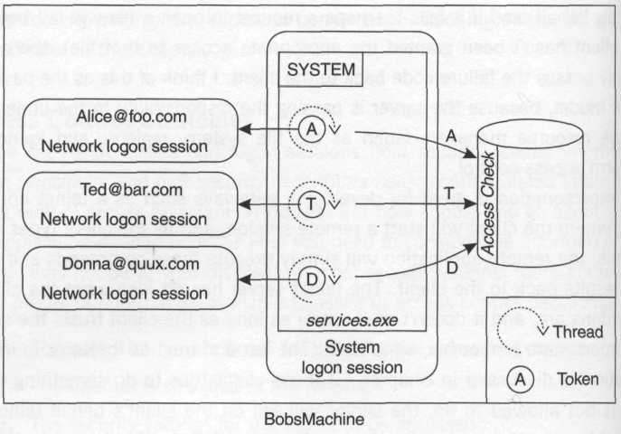
Figure 3.6. Impersonation model

This simple model begins to break down when the objects that a client is interested in are not easily mapped directly to single files or other objects that already have built-in security. Imagine a server that manages text and image files for a document-imaging product. A client's request for a single logical document might be satisfied by opening several files, including text files and images that make up the logical document. In this case, a DACL needs to be applied to each of these files individually, which can get messy. A more difficult problem occurs if the system stores information about multiple logical documents in a single file (perhaps an index). What DACL should be placed on that index file? If the application simply impersonated its clients while it performed all its work, this DACL would need to include all possible clients. The whole point of using a simple impersonation scheme is to avoid having to deal with DACLs in your own application code. You get away with this by assuming that the system administrator will configure the DACLs using the administration tools built in to Windows. This sounds like a maintenance nightmare for the system administrator in this particular scenario.
This model simply melts in a three-tier system, however, because for one thing, prior to Windows 2000, the server could only get a token for a client (in other words, authenticate a client) that was at most a single network hop away. Having the middle tier simply impersonate and call into the back tier (typically a database) is conceptually reasonable, assuming the database provides built-in security, but it is not physically possible on Windows NT 4 because the client is two network hops away from the back tier, and authentication fails in this case.
Even in Windows 2000, where this single-hop authentication limit goes away in certain circumstances, there are other compelling arguments that suggest that access control should not simply be delegated from the second to the third tier via impersonation, including issues dealing with scalability and maintainability. This topic is covered in Chapter 9.

Role-Centric Model
If a server can glean not only the client's authorization attributes (via authentication) but also the client's intentions, it can implement an access control policy built around logical roles. For instance, in an RPC server that simulates a pet store, the server could glean the client's intentions based on the name of the function the client called (perhaps FeedAnimals) and could look in the client's token for an alias that the application had designated as being allowed to perform that action (in keeping with the earlier example, this would be PS_Staff). When the application is installed at Bob's Pet Emporium, the install program would set up these aliases, and Bob would be responsible for assigning these application-specific aliases to appropriate principals and groups in Bob's organization.
As mentioned earlier, support for this model is built in to COM+ in Windows 2000 (MTS in earlier versions of Windows). The reason is clear: COM+ was introduced to make it easier to build scalable three-tier online transaction processing (OLTP) applications, and the framers of COM+ knew that the classic impersonation model wasn't going to scale well. By providing automated role-based access checks via an interception layer (see Chapter 9), COM+ provides an easy-to-implement, easy-to-deploy security model that suffices for many applications.
When programming security, less application code is almost always better than more because it reduces the surface area that you expose to an attacker. (You must assume that the attacker knows every single bug in your code and is just waiting to exploit it.)

Object-Centric Model
Whereas the role-centric model depends exclusively on the authorization attributes and the intentions of a client (and often on the class of the target object), an object-centric model factors in the third question: Which particular object instance is the client after? This third model is the most powerful and flexible, and is the way the operating system itself works in most cases. Of the three models discussed so far, this model clearly requires the most blood, sweat, and tears to implement. However, more and more support is provided with each release of Windows to make it easier to transparently extend the security model used by the operating system to your own application-specific classes of objects.
The idea in this model is that each logical object in an application has an associated security descriptor, just like the secure objects in the operating system itself. One of the most challenging aspects of implementing this model used to be trying to duplicate the behavior of the security editors provided for the file system, the registry, and so forth. For instance, when you use regedt32.exe and choose Security:Permissions to view or edit the DACL for a registry key, a nice little dialog pops up and allows you to add or remove a principal, group, or alias and to choose whether you want to grant or deny certain permissions to that entity. Prior to Windows 2000, this functionality was exposed via an undocumented interface housed in acledit.dll (from what I've heard, it was an interface that only a mother could love), which didn't help independent software developers much.
To solve this problem on Windows NT 4, programmers often would create registry keys (or files) for each of their logical objects and have the administrator edit their DACLs via the built-in ACL editors in the operating system. Later, the application could extract the security descriptors for its own use or simply try to open the key or file corresponding to the logical object requested by the client and let the operating system perform the access checks. Besides feeling kludgy, the problem with this approach is that it only works if your logical object has permissions that map well onto the predefined permissions for files, registry keys, or whatever built-in class of object you happen to be using as a security proxy for your own internal objects.
Windows 2000 remedies this with a brand-new (and much more powerful) editor, which provides a user interface for editing the entire SD, and a well-documented programmatic interface. Given this new editor, the major difficulty becomes managing the storage for the SD. In a three-tier system, where it's preferable to perform access checks as close to the client as possible for scalability reasons (see Chapter 9), the SD for the object must be available to the middle tier without much hassle. (It would be silly to make a round-trip to the third tier to scrape out the SD at each client request.) Clearly some sort of caching and replication strategy will help here.
The final issue is that there is no automatic support in COM+ or MTS for implementing this model. You'll need to learn how to program security descriptors and perform your own access checking, auditing, and the like (this book will help with that).
A much simpler variation on this object-centric model may work if your objects don't require the sophisticated features that a full-blown security descriptor provides. Perhaps your object model is very simple in that there is only one principal (other than a system administrator) who can ever touch an object (perhaps the principal who created it in the first place). In this case, it's very easy to simply store the SID of the creator as a part of the object instead of a full-blown security descriptor. In this case, if an administrator wants to access the object, you can use a role-based decision to grant the administrator full control, and if a normal client wants to access the object, you could compare the client's SID with the SID that you stored with the object at creation time. It wouldn't kill your system to perform the comparison on the back tier, and COM+ propagates the SID of the original caller as out-of-band information with each method call. (This information is not limited to a single network hop, and can be trusted as long as communication over each network hop – client tier to middle tier and middle tier to back tier – is individually authenticated.) If you choose to implement a sophisticated object-centric access control model, be very careful to componentize your access checking logic so that you can rigorously test it with 100 percent code coverage. And, of course, rigorously verify that you are actually using it throughout your code. The more you can automate this, the better.

Choosing a Model
The first decision you should make is the easiest – whether to use impersonation as your primary mechanism for access control. Impersonation simply allows you to pass the buck to the next guy, and if the next guy is the file system or some other secure system whose granularity (and locality) matches that of your object model, then party on. However, in three-tier systems the middle tier can't simply pass the buck and expect to scale well, so you ought to choose a different mechanism.
If you can arrange the interfaces in the middle tier in such a way that you feel comfortable basing your access control policy solely on the interface or method being invoked (coupled with knowledge of the caller's roles), then a role-centric model will make your life easy – incredibly easy if you happen to be writing COM components and can take advantage of COM+ or MTS.
For those of you who need a sophisticated object-centric model similar to the one that Windows exposes, obviously you're left writing code to manage security descriptors. However, the benefit you'll see is tremendous integration with Windows, both in terms of access control and auditing; this book will help you achieve your goal.
All three of these models leverage the notion of single sign on, which means that end users only have to know a single password to unlock not only Windows itself, but also your own application. By taking the time to learn the Windows security model and factor it into your designs, your applications will become more seamlessly integrated with Windows than ever before.

What about Amazon.com?
If you are building a massively scalable Web application that will service millions of online users outside your enterprise, which of the models should you choose? Well, first you have to assume that you won't be able to authenticate 99.99 percent of your users, so the question is somewhat moot. Authentication requires a tightly administered environment; that is, there must be a path of trust from the server to the client's authority if the server is to have any chance of knowing who the client is. What if the server is running on Windows 2000, but the client is running on a Macintosh? Client-side certificates might eventually fill this gap, but public key infrastructures are still pretty new, and we are a long way from deploying this infrastructure to the masses in a standard way. Ultimately, you'll have two types of users in this sort of system: authenticated users (typically administrators or other privileged individuals) and anonymous users. You'll have to treat the anonymous users all the same unless you build in your own application-specific authentication mechanism, which is the model used by Web sites that require registration. (Most people despise having to register with a Web site, so this isn't a great solution for many .com companies.) As far as mapping anonymous users to accounts in your security database, your Web server of choice will do this for you. (For instance, Internet Information Server [IIS] will automatically map all anonymous HTTP or FTP requests to an account called IUSR_MACHINE, where MACHINE is a placeholder for the NetBIOS host name of the machine.) Once this is done, you can choose any of the three models, but keep in mind that all anonymous users will be treated as a single well-known principal as far as the operating system is concerned.

Caching Mechanisms
Windows provides several caching mechanisms that significantly enhance runtime efficiency, and it's incredibly important for the designer of a system-level application to be aware of the ramifications of these mechanisms. Windows security is very much session oriented, in that the runtime performs expensive security checks such as authentication and access control when a logical session is opened; as long as the session is in use, the cost of performing further security checks is negligible. I'll make this concrete by illustrating two of the most important types of sessions: logon sessions and handles.
Recall that when alice@foo.com establishes a logon session on AlicesMachine (perhaps by pressing Control-Alt-Delete and typing in her password), the LSA on AlicesMachine constructs a logon session and a token for Alice that contains all of Alice's authorization attributes. This includes groups from Alice's authority (foo.com), plus aliases and privileges from AlicesMachine. These attributes are cached and flattened in the token for efficiency, in three logical steps:

- All groups in which Alice is a member are included in the token.
- The union of all alias assignments on AlicesMachine that apply directly to Alice or to any of her groups is included in the token.
- The union of all privilege assignments on AlicesMachine that apply directly to Alice, to any of her groups, or to any of the aliases (discovered in step 2) is included in the token.

The effect of this caching mechanism is twofold. First, whenever an access check needs to be performed, there is no need to look up any of Alice's authorization attributes by contacting her authority, because they are already cached in the token. Second, if anything changes after Alice has already established a logon session (for instance, if Alice is granted a new privilege), or if her group or alias assignments change in any way, the current logon session (and any tokens linked to that session) won't be affected by this change. This trade-off in cache coherency versus runtime efficiency is totally reasonable considering that these sorts of changes don't happen very often; even if they did, without the stable environment provided by a logon session, a developer would have to contend with lots of tricky failure modes and race conditions. When Alice closes her logon session and establishes a new session, any new settings will take effect at that point.
An interesting consequence of the distributed nature of Windows' authorization settings is that Alice's token will often look quite different depending on the machine on which she has established the logon session. Figure 3.7 shows an example of two tokens for Alice (abbreviated for brevity): one on AlicesMachine and another on BobsMachine. Notice how in this case the groups have remained the same, but alias and privilege assignments may vary dramatically. The point is that tokens are machine relative. It doesn't make any sense to try to send a token from one machine to another to propagate authorization attributes. The SIDs for custom aliases defined on one machine are completely meaningless to any other machine. Windows also represents each privilege in a fashion that is not guaranteed to have any meaning on another machine (this is totally reasonable considering that tokens are not meant to be shared across host boundaries).

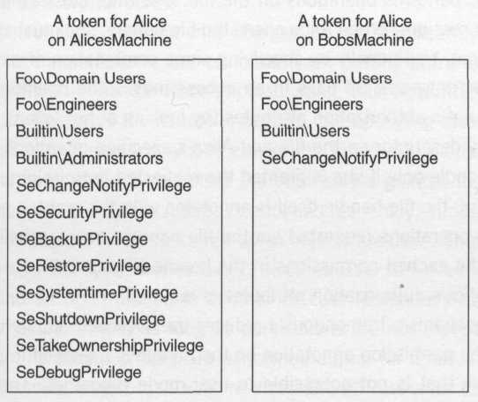
Figure 3.7. Peering into a token

The second type of session is inherent in the programming model exposed by native Windows objects such as files, window stations, and so forth. To take a concrete example, the normal life cycle for file I/O follows a well-known sequence: Alice first opens a file handle (thus opening a logical session to the file object), performs operations on the file, and then closes the handle (thus closing the session). When Alice opens the file handle, she must state her intentions up front, traditionally by specifying some combination of generic_read and generic_write bit flags in an access mask. The operating system will then use Alice's authorization attributes (by looking at her token), coupled with the security descriptor on the file and Alice's specified intentions, and return a valid file handle only if she is granted the requested permissions. In case Alice is successful, the file handle itself is annotated with the granted permissions so that future operations requested via the file handle can be satisfied or refused based on the cached permissions in the handle (Figure 3.8). No further verification of Alice's authorization attributes is required.

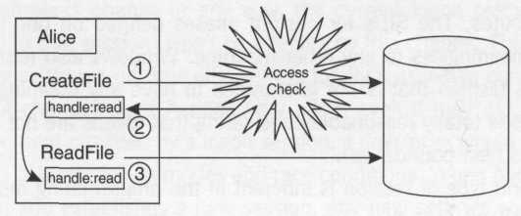
Figure 3.8. Handles act as sessions

This mechanism tremendously reduces the overhead required for providing security. The permission annotation on the handle is managed in protected kernel memory that is not accessible to user-mode processes. The process can continue to use this open session throughout its lifetime, and because the process always runs with a snapshot of Alice's authorization attributes (maintained in the process token), further access checks aren't necessary.
As a result of this mechanism, changes to the object's security descriptor have no effect on outstanding handles. This is something you should consider in your designs. You can always force a new access check by closing the handle and reopening it, or (in certain cases described in Chapter 6), by calling DuplicateHandle.

Impersonation as a Workaround?
Throwing impersonation into the mix changes things significantly, however. Imagine that Alice impersonates Bob temporarily (by putting Bob's token on her thread) and opens a file handle while impersonating, thus acquiring a resource on Bob's behalf. Once this file handle is opened, the operating system doesn't care whether Bob or Alice (or anybody else in the process) uses that file handle, as long as he or she only exercises the permissions granted to Bob when he originally opened the handle. Access control and (generally) auditing are only performed when objects are opened, not when objects are used. Thus Alice can use a handle opened by Bob. The DuplicateHandle API even allows one process to hand an open handle to another process (potentially running in a different logon session), and as long as permissions are not expanded during the duplication, no access checks are performed during (or after) the handoff. So a process running as Bob can acquire and hand off resources to a process running as Alice.
System developers sometimes use impersonation in an attempt to work around the session-oriented nature of Windows security. The classic example is when the developer would like an application to run 24x7 but allow various principals to "log in" to the process at various times during the day, either because the developer considers it too expensive to have someone log off the machine and log back on (recall that when the interactive user logs off, all applications running in the interactive logon session must shut down) or because the application running in the interactive logon session is monitoring or controlling external processes (hardware devices, for example) and thus must run constantly.
Whatever the case may be, what often ends up happening is that the developer attempts to collect credentials on the fly (by presenting the user with a dialog that collects an authority/principal/password tuple), calls LogonUser to obtain a logon session and a token for the user, sticks this token on the main application thread, and begins acquiring resources using these temporary credentials. Although a clever developer can make this work with some very careful programming (and a strong knowledge of Windows security), it becomes very difficult to ensure that the system is secure and is not leaking handles from one principal to the next. Imagine that Alice launches the application, and then Bob (the supervisor) comes along and wants to use it; he thus provides his credentials, and the application starts impersonating him, opening a file handle along with some other resources to do work for Bob. When Bob logs out of the program, the program stops impersonating him and Alice can now use the program again. However, what if the program forgot to close some of the resources that Bob opened? There is no guarantee by the operating system that this won't happen, and it's possible that Alice could end up being allowed to access resources that Bob acquired, with permissions that she would not normally be granted. To be completely safe, the process should close all outstanding handles acquired on behalf of the previous principal, and should reopen those resources on behalf of the new principal. Might as well shut down the process and restart it, eh?
To solve this classic problem, it is helpful to split the application into two separate processes, with some sort of secure interprocess communication between the two (COM is a very natural choice here). The core part of the application runs as a daemon process and will not be tied to the interactive logon session (in fact, it may even run in the System logon session if that is desirable). This daemon process can safely run 24x7, and is not affected by the coming and going of interactive users. The user interface can then be partitioned into a separate process running in the interactive logon session, and should be as lightweight as possible to facilitate a quick startup and shutdown. For vertical applications, it's often convenient to replace the shell itself (explorer.exe) with the user interface program to reduce login latency even further. This trick also makes it considerably more difficult for average users to install or run random software from the console. The daemon process can perform access checks on COM method calls using one of the three strategies outlined earlier, and can acquire resources using the daemon's credentials (as opposed to using the client's credentials) as necessary.
The moral of the story is that you should understand the session-oriented nature of Windows security and make it work for you, rather than against you. This sort of example also demonstrates how considering security in the design phase of any nontrivial project can be critical. Retrofitting security into an existing application is often a painful proposition; this may explain why so many developers are frustrated by security.

Summary
- If authentication answers the question "Who are you?" then authorization answers the question "What can you do?"
- Authorization attributes in Windows consist of groups, aliases, and privileges, and these attributes are generally assigned in a decentralized fashion.
- Privileges are assigned on a per-machine basis, but this can be automated with group policy objects in Windows 2000 or the Security Policy Editor in earlier versions of Windows.
- Aliases are assigned on a per-machine basis and are traditionally used to model logical roles.
- Group assignments are managed by an authority; thus, they have a wider scope than aliases and are traditionally used to model an organization (the Appendix has more details on groups in Windows 2000).
- When a logon session is established, the system takes the union of the authorization attributes from the relevant authorities (groups) and the local authorization attributes (aliases and privileges) and caches them in a token.
- Distributed applications can use network authentication to establish a network logon session on a server for each remote client. This allows the server to get a token for the client that contains the client's authorization attributes.
- A security descriptor is a data structure that contains all the security settings for an object (perhaps a file, registry key, process, or a custom class of object that you define). This includes an owner, discretionary access control list (DACL), and system access control list (SACL).
- The DACL is basically a list that says who can touch the object and in exactly what way. The DACL is specified at the owner's discretion (thus the word discretionary).
- The SACL is a list that says who will be audited if they succeed or fail while attempting to touch the object in a particular way. The SACL is nondiscretionary; the owner has no special permissions to the SACL.
- There are three idiomatic models for performing access control in Windows: the impersonation model, the role-centric model, and the object-centric model. (These are arranged in order of complexity.)
- The impersonation model works great if you can pass the buck directly to a local resource manager that performs its own access checks.
- The role-centric model focuses on the roles to which a principal has been assigned. The Administrators alias is a great example of a logical role upon which the operating system itself relies.
- The object-centric model is the most powerful and therefore the most complex to implement and administer. Each object maintains its own security settings (usually this takes the form of a security descriptor).
- Windows security is session oriented. Logon sessions and handles are two examples of sessions you'll encounter.
- Access checks on operating system objects are only performed when you open a handle. Giving the handle away (via impersonation or DuplicateHandle) has interesting security ramifications because no further access checks will be performed.

This assumes your domain is in native mode, which implies that all your domain controllers are Windows 2000 machines. See the Appendix for more details on groups in Windows 2000.
Note that on Windows 2000, custom aliases cannot be created on machines that are domain controllers, so you may want to consider using nested groups where you would have used an alias on that platform. Domain local groups work well for this.
Domain controllers (DCs) in Windows NT 4 are an exception, in that all domain controllers for a particular domain share a common security database, including a common set of aliases and privileges; thus, any privilege assignments granted on the PDC percolate to all the BDCs in the domain.
Even with a COM server, the server must be running (granted, server launch may be automated somewhat by the COM SCM, but nonetheless the server process must ultimately be running) before a client can successfully make a method call into the server.
I've made a conscious choice here to ignore the Run As Activator feature in COM, which is virtually never used for distributed applications but is the most appropriate choice for nondistributed applications. This option is discussed in Chapter 9.
Technically, the file system redirector does add an extra level of access checks, because it must verify the client's access permissions to the file system share before attempting to do any work on the client's behalf. However, because the file system redirector impersonates Alice before accessing the file, this will never widen Alice's permission to the file – it will only serve to narrow those permissions. Alice must cross two hurdles as opposed to just one.
This tool can also be installed on Windows NT 4.0 Service Pack (SP) 4 (or greater), but it's not redistributable – it must be installed by the end user as part of the Security Configuration Editor add-on. See the SP4 readme file for more details.
Of course, you should be very careful when sending this type of critical security policy information over the wire: It should at least be signed to protect it from external tampering.
Be aware that although COM+ supports method-level granularity for setting access control via roles, MTS only supports interface-level granularity.
Some third-party middleware such as Site Server provides this functionality.
When you install IIS, the setup program adds this account, but you can change the principal and credentials used on a per-resource basis
See Chapter 6 for more details.
This presents its own share of problems – recall that you want to avoid putting up dialog boxes that prompt the user for credentials because it makes it easier for a Trojan horse to mimic your dialog and steal passwords.
As shown in Chapter 4, only very privileged principals can call this function; administrators don't even have this privilege by default. This in itself should be a warning sign.

